Pandemic Sunny Days
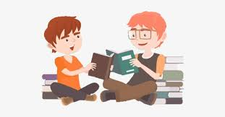

Book / Article Sharing

Name: Wong Tsz Yan, Hazel Class: 4C ( 25 ) Date: 22nd February, 2021

Book / Article Title: From unsung hero to cultural icon
Author (if any): _____________________________________________________
Publisher / Source: Student Standard


Summary:

Masks -- have suddenly become our daily necessities in the past year because of Covid-19. Until now, masks have already become a political object, an artistic canvas. Some Asian countries have started to wear masks since 2019 to protect themselves in order to make fewer infections and deaths. But in western countries, many people resist to wear a mask on. This makes masks become a political standpoint. In addition, wearing masks has become a part of fashion. Many new patterns and styles are constantly being introduced on the market to make people feel fresh about wearing masks.

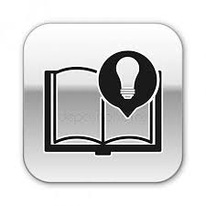
The most surprising / inspiring scene / fact:

The most surprising thing is the creative masks design. They can appear both aesthetically and functionally. I appreciate the design ‘connected’ smart masks, it can transmit messages and translate Japanese into eight other languages.

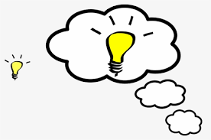
Opinion / Reflection:
- How does Covid-19 affect your life?
- What attitude should we have under the influence of Covid-19?

Covid-19 affects my life a lot. First, we can’t go to school to study. We need to stay at home and have Zoom lessons. Because of using the electronic screen for a long time, my myopia has been increased by 50 degrees and I realize that we must protect our eyes. Second. I can’t do what I like. For example, I can’t dance for a long time and all the competitions and dancing exams are cancelled. These make e feel bored about my life.

Under the influence of Covid-19, we always need to stay at home, wear a mask when you go out, always wash hands and use alcohol. Be careful to the human contact and droplets spread, too.

